Kinetic MUNANA App

A User Manual

# Introduction

The Kinetic MUNANA App is designed to study enzymatic activity of influenza A neuraminidase (NA) and the effects of specific monoclonal antibodies on its function in kinetic MUNANA assay. During the assay a weakly fluorescent 2′-(4-Methylumbelliferyl)-α-D-N-acetylneuraminic acid (MUNANA) is converted to a brightly fluorescent 4-methylumbelliferone (4-MU). Measuring fluorescence intensities in real time allows one to estimate reaction velocities at different substrate concentrations. Knowing these parameters, one can calculate parameters of Michaelis-Menten equation (Km and Vmax) of the enzyme and how they change in the presence of antibodies.

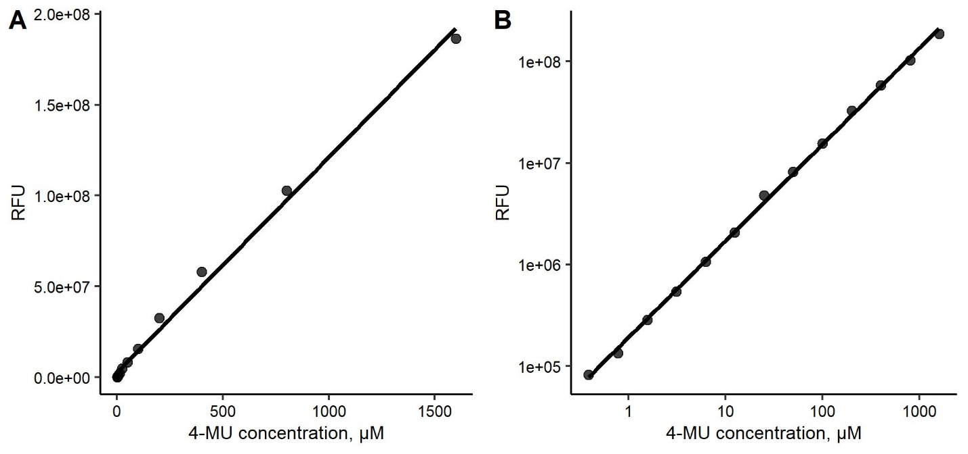

*Fig. 1. Calibrating titration of 4-MU in linear scale (A) and log scale (B).*

General scheme of data processing in MUNANA assay had been described earlier [Marthe et al., 2013]. We developed an easy-to-use application allowing data processing according to the scheme described in the article. However, we also introduced three main modifications. First, instead of building a linear regression between optical data and 4-MU concentration in standard titration curve (Fig. 1A), the app log-transforms these values to get more accurate mathematical description of the relationship between optical signal and 4-MU concentration (Fig. 1B). However, the app provides a user an option to calculate linear models based on non-transformed data (Fig. 1A), by setting calibration method to ‘Linear’. Second, we suggest a correction to eliminate the effect of weak MUNANA fluorescence on the estimates of 4-MU concentration. In the beginning of the reaction, the substrate concentration is maximal; meaning the contribution of its fluorescence to entire signal is also maximal. During the assay, NA converts the substrate; therefore, its contribution to fluorescence proportionally decreases over time (Fig. 2). Knowing the fold difference in brightness of the substrate and product, a correction of original data to eliminate the effect of substrate fluorescence could be done. The app allows estimation the difference between substrate and product fluorescence and use this number for data correction. Finally, 4-MU fluorescence slightly decreases over time due to photobleaching and thermal damage (Fig. 3). To compensate this effect the app builds standard curves for each time point of the assay.

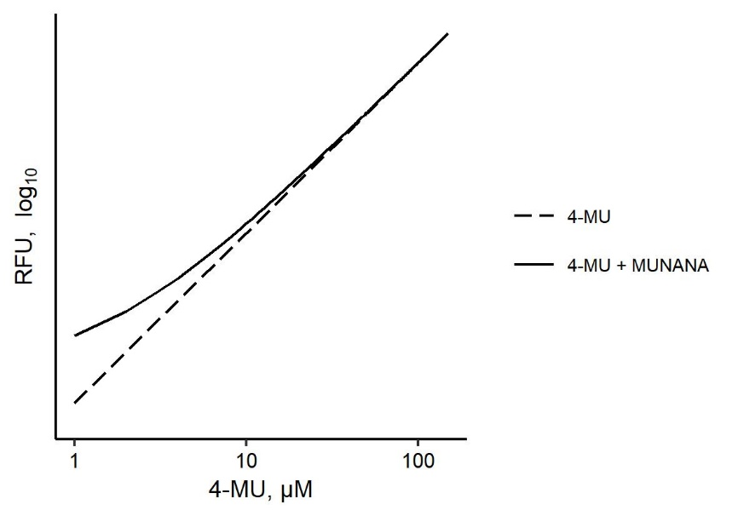

*Fig. 2. Contribution of MUNANA fluorescence into optical signal from reaction depending on actual 4-MU concentration.*

The app estimates values of Km and Vmax, the parameters of Michaelis-Menten equation, and their 95% confidence intervals fitting non-linear least-squares (NLS) models to obtained velocity data. Initial guesses of Km and Vmax values for the NLS models are picked up automatically based on regression parameters of reciprocal values []. However, a user has an option to correct initial guesses if automatic algorithm leads to non-converting models. And the last but not least, if two or more samples are studied the app makes statistical inference about Km and Vmax values comparing them with a selected reference.

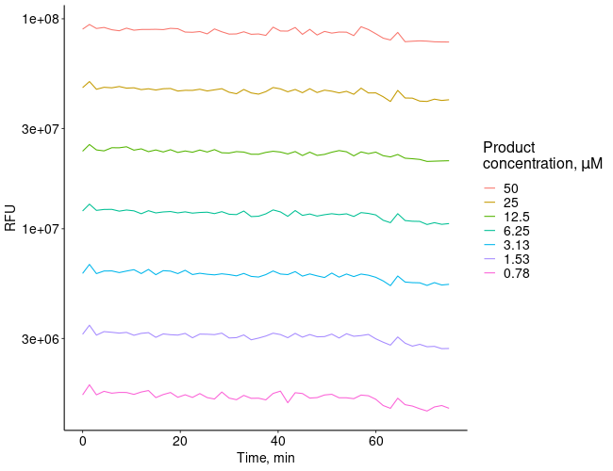

*Fig. 3. The optical signal from standard titration during the assay.*

All plots and data could be saved into a MS Word file or exported as an Excel table for further analysis.

The app is available online (<https://angeletti-lab.shinyapps.io/kinetic-munana-app/>).

# Local installation

The app could be locally installed. Data processing is implemented using R programming language. The graphical user interface requires Java to function. Therefore both should be installed on a computer to launch the app.

The following instruction is valid for Windows machines:

1. Install R (version 4.0.5 or higher): <https://cran.r-project.org/bin/windows/base/>
2. (*Optional*) Install RStudio: <https://www.rstudio.com/>
3. Install Java for Windows (64-bit version) if it is not already present on the machine: <https://www.java.com/en/download/manual.jsp>
4. Download the folder with the app from our git-hub account () and copy it into the desired location.
5. Execute the before_first_start.R script. If the rtools package is properly installed (no warning messages popes up). If it is not installed, try to install it separately from here: <https://cran.r-project.org/bin/windows/Rtools/>. Next, re-run before_first_start.R script.
6. Open the App.R script in RStudio or any other text editor. On the top of the file, change the path variable to the current location of this file. Note the direction of slash symbols in the path value (should be ‘/’, not ‘\’).
7. Repeat the previous step with the run.r file.
8. Open the MUNANA App.bat file in any text editor. Change the first address for the location of R.exe file in your machine, and the second address for current location of the run.r file.
9. Double click on MUNANA App.bat file to launch the application. It should appear in default web browser.

# How to use the app

All data is provided in a form of three Excel files: standard table, sample table, and RFU data table. Templates for all three tables could be generated by the application. The user needs to specify the ranges of columns used in each of them and hit corresponding ‘Save Template’ buttons. If file’s content does not satisfy the app requirements listed below error messages appear instead of tables. To exclude some wells from the analysis, their names should be removed from the standard or sample table while RFU data table may still contain the data.

**Standard table**

The standard table file describes the location of the wells containing serial dilutions of 4-MU with known concentrations as well as negative controls wells containing pure buffer (Fig. 4). The standard table must contain three columns: ‘well’, ‘type’, and ‘conc’. The first column contains well names (start with capital letters). Second column has one of two values: either ‘standard’ (for wells containing 4-MU) or ‘NC’ (for wells containing working buffer). The ‘conc’ column contains concentrations of the reaction product in μM.

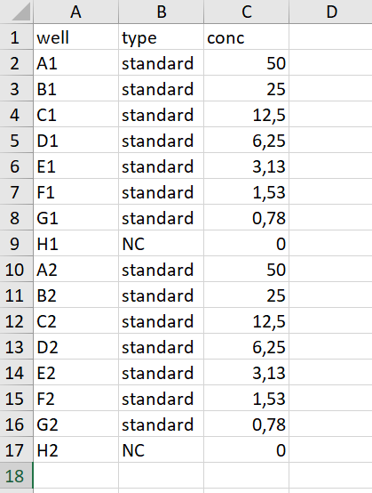

*Fig. 4. An example of a standard table.*

**Sample table**

The sample table file contains three columns describing samples: ‘well’, ‘name’, and ‘substrate_conc’ (Fig. 5). The first column is similar to one from first file (but there should no common wells in two files belonging to one experiment). The ‘name’ column contains names of samples studied in the experiment. All wells containing the same sample must have identical names; otherwise, they are recognized by the app as different once. The last column contains concentrations of the substrate present in wells before the assay. Samples could be analyzed in duplicates, triplicates, etc. The app calculates reaction velocities for each well independently but Km and Vmax values are calculated based on all data belonging to each sample.

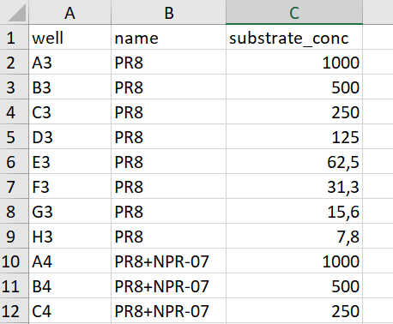

*Fig. 4. An example of a sample table.*

**RFU data table**

RFU table is an Excel file containing optical data from a spectrophotometer (Fig. 6). It should contain columns of two kinds: ‘Time’, containing time points at which the measurements were taken, and well names with optical data. Any other columns, if present, are negated. This kind of table could be directly exported from the software of the SpectraMax i3x reader. The user must specify time format used in this file before uploading it into the app. By default, it recognizes the Excel format, meaning it is presented as a fraction of a day passed since the moment the assay started and normally represented in Excel in H:MM:SS format. However, time data could be provided in a form of seconds, minutes, or hours passed since the beginning of the assay. The time format should be specified before uploading the Excel file.

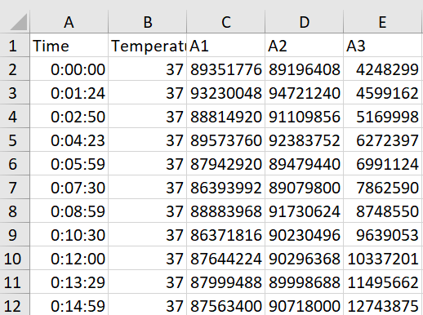

*Fig. 6. An example of RFU data table.*

**Standard tab**

After uploading all files, proceed to the ‘Standard’ tab to calculate linear regressions describing relationships between 4-MU concentrations and its fluorescence. By default, the app log-transforms both these variables and builds linear regression models (Calibration method: Log-linear) for each assay time point (Fig. 1B). We consider this approach as a precise method to convert optical data into 4-MU concentrations. However, by choosing ‘Linear’ calibration method a user may use a traditional way to do this transformation (Fig. 1A).

If the brightness difference between 4-MU and MUNANA is known (see below), a correction for MUNANA weak fluorescence could be made. To do this the ‘Brightness Correction’ checkbox should be clicked on and the value of the brightness difference entered.

Upon clicking the ‘Calculate’ button, a series of linear regression models for each assay time point are calculated and two figure spaces appear. The upper one contains the standard plot showing the change of log-transformed fluorescence intensities in wells with standard titration of 4-MU (Fig. 3). If more than one series of standard titration present in the assay, the app shows the averaged signals for each 4-MU concentration. To show individual signals, figure mode should be changed to ‘Individual’. This plot helps the user to detect abnormal values in standard titration and eliminate corresponding wells from the analysis.

The lower figure space contains three plots showing the change of the regression parameters of the calibration curves (slope, intercept and R2) over the assay. By default, the Y scale is picked up to show all the variation in these parameters. The user is allowed to change the Y scale manually to see only meaningful variations in these parameters if they exist.

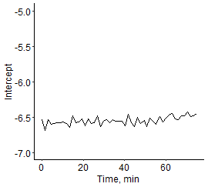 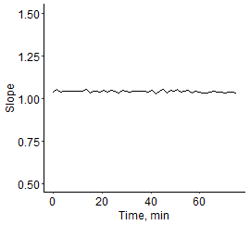 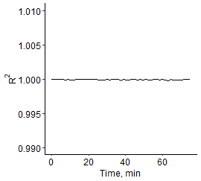

*Fig. 7. An example of plots showing the change of standard curve parameters (intercept, slope, and R2) over the assay.*

**Progress curves tab**

Navigating to the ‘Progress curves’ tab, the user can see progress curves generated during the assay. They show accumulation of the reaction product (in μM) in sample wells. Three modes of this plot are available. By default, the application shows all progress curves for each sample in separate panels (Fig. 8). By selecting ‘All in one’, the user may put all the curves in one plot, or by selecting ‘By sample & concentration’, the user can generate a series of plots for each level of substrate concentration for each sample.

By clicking the ‘Show velocities’ check-box, the user can see dashed lines representing calculated reaction velocities to each well. If the optical signal from wells increases linearly, the dashed lines are in fact linear regression models of corresponding data. However, if the curves bend and level-off during the assay, only initial reaction velocities are calculated. Therefore, dashed lines coincide with the data only in the beginning of the assay.

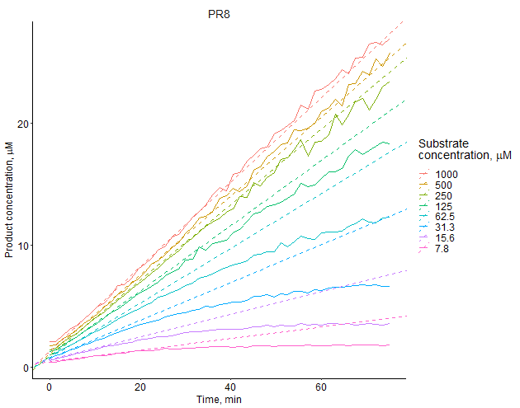

*Fig. 8. Progress curves and reaction velocities estimates (dashed lines) obtained in an experiment with PR8 virus.*

**Michaelis-Menten models tab**

The next tab contains Michaelis-Menten models calculated for each sample by fitting non-linear least-squares models to the velocity data. The upper two sections on this tab allow inspection of individual samples. The left bar contains a select picker allowing to change sample data demonstrated on the main space. The Velocity Data table contains regression coefficients and R2 obtained by fitting a quadratic regression model (y = ax2 + bx + c) to the velocity data. Check our publication for further details [].

Below the table a Michaelis-Menten plot for the selected sample is shown (Fig. 9). Red dashed lines show location of ½ Vmax (horizontal line) and Km (vertical lines). Non-linear least-squares model summary, estimates of Vmax and Km, and their 95% confidence intervals are provided to the right. If the model does not converge with automatically guessed Vmax and Km values, the user may try to pick initial values Vmax and Km values. To do this, the model curve should be removed from the plot to see the data points by ticking off the ‘Show model’ checkbox. When approximate values of Vmax and Km are established, the user should tick on the ‘Manual guess of Vmax and Km’ on the left bar and enter corresponding values. After that the app tries to converge the model with new values, and if successful, it saves new results in the Result Table shown in the bottom of the tab.

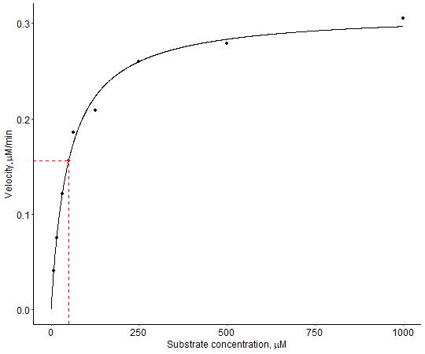

*Fig. 9. Michaelis-Menten plot showing reaction velocities depending on substrate concentration.*

On the bottom of this tab, the Result Table is located. It contains Vmax and Km values and their 95% confidence intervals for all the samples studied in the experiment.

The velocity data and the result table could be saved in a form of Excel file for further data analysis.

**Plots tab**

The ‘Plot’ section contains a figure overlaying all Michaelis-Menten curves generated on the previous step. By ticking on and off the check boxes on the left bar, the user can select curves overlaid on the plot. If all the check boxes are ticked off, the application shows all the curves again. To the right of this plot, a fraction of the result table is shown containing the data only from selected samples.

Underneath the plot with Michaelis-Menten curves, there is a scatter plot showing Km and Vmax values of the selected samples and 95% confidence bars. The bars could be removed from the plot by ticking off the check box below.

**Statistics tab**

The statistics tab appears only if provided data set contains two or more samples. It shows the results of pairwise comparisons of Vmax and Km values of a reference sample with the other ones. The reference samples could be selected by the user on the left bar. The first columns of the tables show actual values of Vmax and Km calculated on the previous steps. The second column (‘change’ column) shows the how these values were changed in the experiment compared to the reference sample. The ‘p.value’ column shows p-values calculated during the pairwise comparison of the studied samples and the reference one. The next column (‘p.adjust’ column) contains adjusted p-values for multiple comparisons. The method of adjustment could be selected on the left bar by the user. The last column (‘stars’ column) shows a star representation of the adjusted p-values based on the following rule: * - p < 0.05, ** - p < 0.01, *** - p < 0.001.

**Report tab**

Moving to the ‘Report’ tab, the user can save generated plots and calculated data in a Word file. By filling the title filed, the user can entitle his or her experiment, select its data, and select included items by ticking on the check boxes on the left bar. Generated MS Word file contains plots in the way they are presented in the application at the moment the user clicks the ‘Save Report’ button.

**Utilities: Estimation of the brightness difference of reaction substrate and product**

To estimate the brightness difference of reaction substrate and product, the user should make serial dilutions of both and make several wells with working buffer only. Then, optical signal from all the wells should be measured using the working settings of the plate reader. Collected data should be uploaded to the application in the form of an Excel file containing a table of four columns: ‘conc’, ‘substrate’, ‘product’, and ‘buffer’ (Fig. 10). The first column should contain concentrations of the substrate or product (in μM). The ‘substrate’ and ‘product’ column should contain optical signals from wells with substrate and product, respectively. The last column should contain optical data obtained from wells with working buffer only.

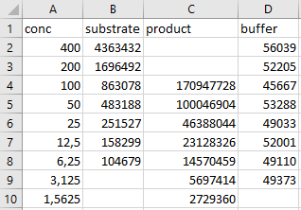

*Fig. 10. An example of a table with optical signals from reaction substrate and product.*

When the file with data is uploaded to the application, a plot showing titration of the substrate and product is generated (Fig. 11). Two corresponding regression linear models are generated assuming that the slopes of two lines equal to -1, meaning dilution of the substances twice leads to a double reduction in their brightness and any deviation from this rule is random. The difference between the intercepts of two models represents the difference in the brightness of two substances.

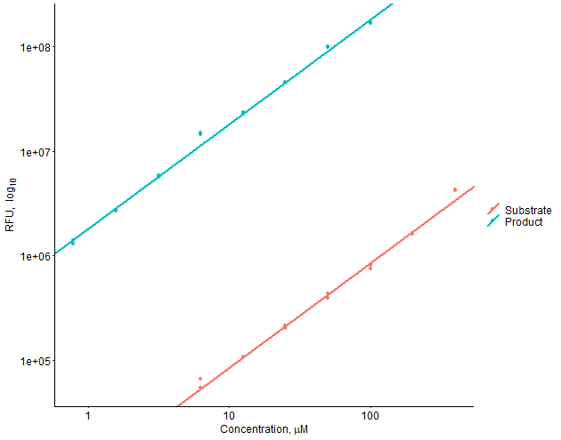

*Fig. 11. A plot showing the difference of 4-MU (the product) and MUNANA (the substrate) in brightness.*

**Utilities: Spectrum analysis of substrate and product**

To carry out a fluorescence spectrum analysis of reaction substrate and product, the user needs to measure their optical signal at different wavelengths and upload this data to the application in a form of an Excel file. This file should contain four columns: ‘wavelength’, ‘substrate’, ‘product’, and ‘buffer’ (Fig. 12). All these columns should contain optical signal from corresponding substances recorded at indicated wavelengths. The application automatically determines maximal fluorescence intensity of the reaction product and marks it by vertical line. The user can specify the bandwidth a spectrophotometer will use to measure optical signal during assays. It is represented on a plot as a grey area. Also, the user can show individual data points on the plot and switching between log and linear Y scales by ticking on and off the corresponding checkboxes on the left panel (Fig. 13).

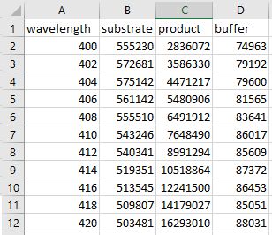

*Fig. 12. An example of a table with optical signals from reaction substrate, product, and working buffer at different wavelengths.*

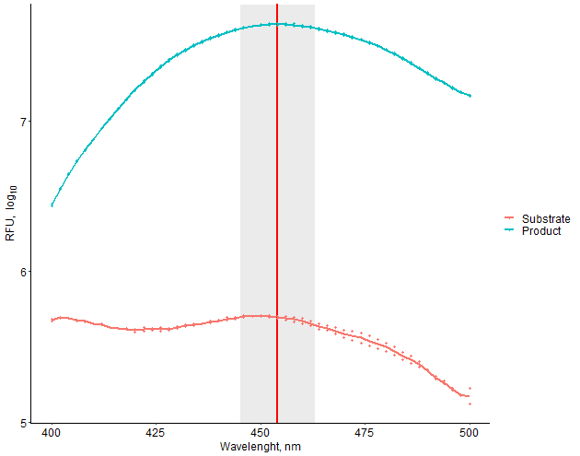

Fig. 13. Fluorescence spectra of 4-MU (the product) and MUNANA (the substrate) are overlaid on the plot with log Y scale.

# References

1. Marathe BM, Lévêque V, Klumpp K, Webster RG, Govorkova EA. Determination of neuraminidase kinetic constants using whole influenza virus preparations and correction for spectroscopic interference by a fluorogenic substrate. PLoS One 2013 Aug 15;8(8):e71401.